
[1]

Tribhuvan University
Faculties of Humanities and Social Sciences
A PROJECT REPORT
On
Quick Commerce App (GroceryPlus)

Submitted to
Department of Computer Application
Orchid International College
In partial fulfillment of the requirements for the Bachelors in Computer Application

Submitted by
Sunit Dangaura Tharu (93902154)

January, 2025

Under the Supervision of
Er. Dhiraj Kumar Jha


Tribhuvan University
Faculties of Humanities and Social Sciences
Orchid International College

SUPERVISOR’S RECOMMENDATION
This is to certify that the project entitled Quick Commerce App (GrocryPlus) is prepared under the supervision of Sunit Dangaura Tharu [93902154] in partial fulfilment of the requirements for the degree of Bachelor of Computer Application is recommended for the final evaluation.

SIGNATURE
Er. Dhiraj Kumar Jha
SUPERVISOR
Project Coordinator
Department of IT
Orchid International College,Bijaya Chowk, Gaushala



Tribhuvan University
Faculties of Humanities and Social Sciences
Orchid International College

LETTER OF APPROVAL
This is to certify that this project prepared by Sunit Dangaura Tharu [93902154] entitled Quick Commerce App (GroceryPlus) in partial fulfillment of the requirements for the degree of Bachelor in Computer Application has been evaluated. In our opinion, it is satisfactory in the scope and quality of a project for the required degree.
SIGNATURE of Supervisor  Er. Dhiraj Kumar Jha, Project Coodinator  Department of IT  Orchid International College  Bijaychowk, Gaushala | SIGNATURE of HOD/ Coordinator  Er. Dhiraj Kumar Jha, Project Coordinator  Department of IT  Orchid International College  Bijaychowk, Gaushala
SIGNATURE of External Examiner

ABSTRACT
The GroceryPlus System refers to a mobile-based quick-commerce platform designed to manage grocery products, user accounts, orders, and payments efficiently. This system provides a convenient and user-friendly interface for browsing, selecting, and purchasing groceries online, incorporating integrated payment methods to facilitate seamless transactions. Developed to operate 24/7, the platform is tailored to meet the diverse needs of customers in Nepal. The system follows agile development methodology, enabling incremental delivery and continuous feedback from stakeholders. GroceryPlus is built using Java, XML, SQLite, and Android SDK
Keywords: Quick Commerce(GroceryPlus), Java, XML, Android SDK, SQLite, FireBase

ACKNOWLEDGEMENT
I would like to express our heartfelt gratitude to everyone who has supported and guided us throughout the development of this project, the quick-commerce platform named GroceryPlus.
First and foremost, I would like to extend our sincere thanks to our project supervisor, Er. Dhiraj Kumar Jha, for his invaluable guidance, insightful feedback, and continuous encouragement. His expertise and support have been instrumental in shaping this project.
I am also deeply grateful to Mr. Dhiraj Kumar Jha for their constructive feedback, motivation, and insightful suggestions, which greatly contributed to the successful completion of this work.
I would like to acknowledge our institution, Orchid International College, for providing the necessary resources and a conducive environment to undertake this project.
Special thanks go to our peers, friends, and families for their unwavering encouragement and support throughout this journey. Their belief in us has been a constant source of motivation.
Finally, I acknowledge the invaluable contributions of small business owners, entrepreneurs, and quick-commerce enthusiasts worldwide, whose dedication to innovation and digital commerce inspired the concept of Quick Commerce App (GroceryPlus). This project is a collective effort aimed at promoting local businesses and fostering a convenient shopping experience for all users.

Sunit Dangaura Tharu [93902154]

Table of Contents
SUPERVISOR’S RECOMMENDATION i
LETTER OF APPROVAL ii
ABSTRACT iii
ACKNOWLEDGEMENT iv
List Of Figures vii
List of Tables viii
CHAPTER 1: INTRODUCTION 1
1.1 Introduction 1
1.2 Problem Statement 1
1.3 Objectives 1
1.4 Scope and Limitation 2
1.5 Development Methodology 2
CHAPTER 2: LITERATURE REVIEW 3
2.1 Background Study 3
2.2 Literature Review 3
CHAPTER 3: SYSTEM ANALYSIS 4
3.1 System Analysis 4
3.1.1 Requirement Analysis 4
3.1.2 Functional Requirements 4
3.1.3 Non-Functional Requirements 7
3.1.4 Feasibility Analysis 7
3.1.5 Data Modeling 7
3.1.6 Process Modeling 9
CHAPTER 4: SYSTEM DESIGN 11
4.1 Design 11
4.1.1 Sequence Diagram 11
4.1.2 Activity Diagram 12
4.1.3 Class Diagram 14
4.1.4 Component Diagram 14
4.1.5 Deployment Diagram 16
CHAPTER 5: IMPLEMENTATION AND TESTING 18
5.1 Implementation 18
5.1.1 Tools Used 18
5.1.2 Implementation Details of Module 18
5.2 Testing 18
5.2.1 Unit Testing 19
5.2.2 Integration Testing 20
5.2.3 System Testing 20
CHAPTER 6: CONCLUSION 21
6.1Conclusion 21
6.2Future Recommendations: 21
References 22
APPENDICES 23

List Of Figures
Figure 1.1 Development Methodology – Waterfall Model………………………..………2
Figure 3.1 Use-Case Diagram of Quick Commerce(groceryPlus) ….………………….....5
Figure 3.2 E-R Diagram of Quick Commerce(groceryPlus)….…………………………...8
Figure 3.3 Class Diagram without method of Quick Commerce(groceryPlus)…..…….....10
Figure 4.1 Sequence Diagram of Quick Commerce(groceryPlus).….……………………12
Figure 4.2 Activity Diagram of Quick Commerce(groceryPlus)….……………………..13
Figure 4.3 Class Diagram of Quick Commerce(groceryPlus)…..………………………..14
Figure 4.4 Component diagram of Quick Commerce(groceryPlus)….…………………..15
Figure 4.5 Deployment Diagram of Quick Commerce(groceryPlus)…...…………….…..16

List of Tables
Table 3.1 Use-Case Description for User Login………………………………………6
Table 3.2 Use-Case Description for Browse Product………………………………….6
Table 3.3 Use-Case Description for Process Order……………………………………6
Table 5.1 Unit Testing for Login Module…….………………………………………19

CHAPTER 1: INTRODUCTION

Introduction
Quick Commerce App(GroceryPlus) is an quick-commerce platform where users can browse and purchase products conveniently online. The term quick-commerce refers to the buying and selling of goods and services over the internet, providing users with the ability to shop from the comfort of their homes. Quick Commerce App(GroceryPlus) is designed to handle product listings, user accounts, orders, and payments efficiently.
Quick Commerce App(GroceryPlus) is a android-based application tailored to the needs of small and medium-sized businesses in Nepal. It allows users to browse products, place orders, and make payments online. The system integrates Stripe for secure and seamless payment processing, ensuring convenience for customers. Additionally, Quick Commerce App(GroceryPlus) facilitates 24/7 operations to cater to the growing demands of the local market.

Problem Statement
Small and medium-sized businesses in Nepal lack a fully digitized quick-commerce platform with integrated payment systems. This makes it challenging for sellers to manage their products and orders efficiently, while customers face difficulties in making seamless online transactions.
To address this, Quick Commerce App(GroceryPlus) is designed to handle the complete lifecycle of online shopping, from browsing products to placing orders and making payments. The platform incorporates an external payment gateway (Stripe) to facilitate secure and efficient transactions, eliminating the need for offline or manual payment processes.

Objectives
The following are the objectives of the Quick Commerce App(GroceryPlus)project:
- To develop a comprehensive android-based quick-commerce platform for managing products, users, orders, and payments.
- To follow all the phases of the Software Development Life Cycle (SDLC) during the project's development.
- To integrate an external payment method (Stripe) for secure and seamless transactions.

Scope and Limitation
Quick Commerce App(GroceryPlus) will serve as an quick-commerce platform for businesses and consumers in Nepal. The system allows users to browse products, place orders, and make payments securely using an integrated payment gateway. Administrators can manage the product catalog, update inventory, and oversee order processing.
However, Quick Commerce App(GroceryPlus) has the following limitations:
- It does not provide user location-based features, such as nearby store recommendations or delivery tracking.
- The payment system relies on an external gateway (Stripe) and does not have an in-house payment processing system.
- The system is designed for a limited user base and may not support high-traffic scenarios or extensive data loads.

Development Methodology
We have used Waterfall Method for developing our system. This method was chosen because of its simplicity and ability to cope change. This method is suitable for fast changing environment where feedbacks are taken frequently to incrementally develop the system.
The following diagram show the development process in Waterfall Methodology:
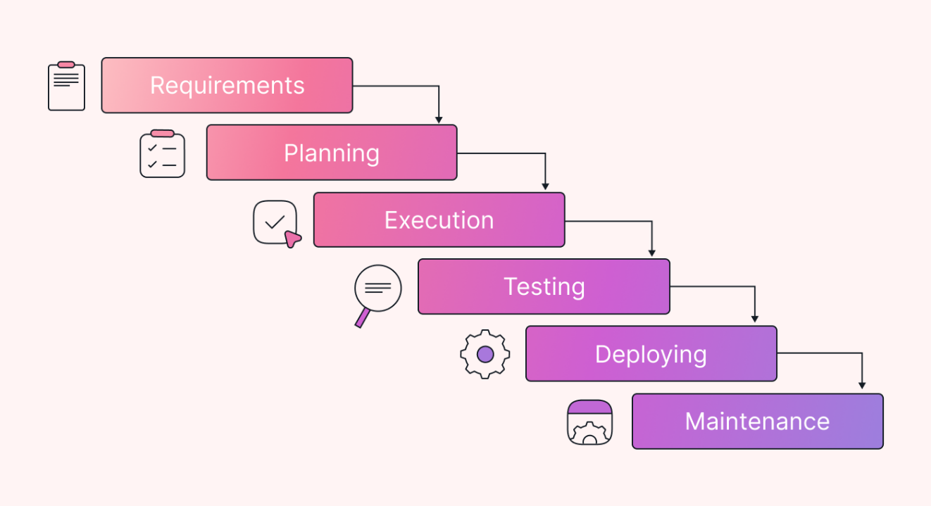
Figure 1.1 Development Methodology – Waterfall

CHAPTER 2: LITERATURE REVIEW

2.1 Background Study
Over the years, many systems have been developed to facilitate quick-commerce platforms. These systems cater to various requirements, such as product management, online payments, and order tracking. Large organizations like Amazon, Alibaba, and Flipkart have established quick-commerce platforms to meet customer demands globally.
In Nepal, however, the adoption of fully digitized quick-commerce platforms has been slower, particularly for small and medium-sized businesses. Many sellers still rely on manual processes or social media platforms for their operations. Quick Commerce App(GroceryPlus) aims to fill this gap by providing an affordable and easy-to-use platform tailored to the local market's needs. This platform is designed to help sellers streamline their operations and offer a better shopping experience to their customers.

2.2 Literature Review
Quick-commerce refers to the buying and selling of goods and services over the internet. It has revolutionized the retail industry, offering convenience and efficiency for both businesses and consumers.
Many studies highlight the benefits of Quick Commerce , such as increased accessibility to a wider customer base, reduced operational costs, and streamlined payment processes through digital wallets or payment gateways. [1]
Traditional business operations, especially in developing countries like Nepal, often rely on manual methods for record-keeping and customer interactions. These methods are time-consuming and prone to errors, especially when scaling operations. [2]
Quick Commerce App(GroceryPlus) addresses these issues by providing a digitized solution for sellers, integrating features such as product management, order tracking, and digital payments. The use of external payment systems, like Stripe, ensures secure and efficient transactions, further enhancing the user experience. [3]

CHAPTER 3: SYSTEM ANALYSIS

3.1 System Analysis

3.1.1 Requirement Analysis
Requirement analysis, also known as requirements engineering, is the process of identifying and documenting user expectations for a new or updated quick-commerce platform. These requirements must be clear, quantifiable, and relevant. The process involves continuous communication with users and stakeholders to determine feature expectations, resolve conflicts or ambiguities, prevent feature creep, and ensure thorough documentation throughout the project lifecycle.

3.1.2 Functional Requirements
Functional requirements define the core services and features that the Quick Commerce App(GroceryPlus) platform must provide. These describe the platform's inputs, behaviors, and outputs, ensuring it meets user needs effectively. Functions may include data manipulation, user interaction, and business process automation.
The following is the use case diagram that describes different functionalities of the system and interaction between actors.

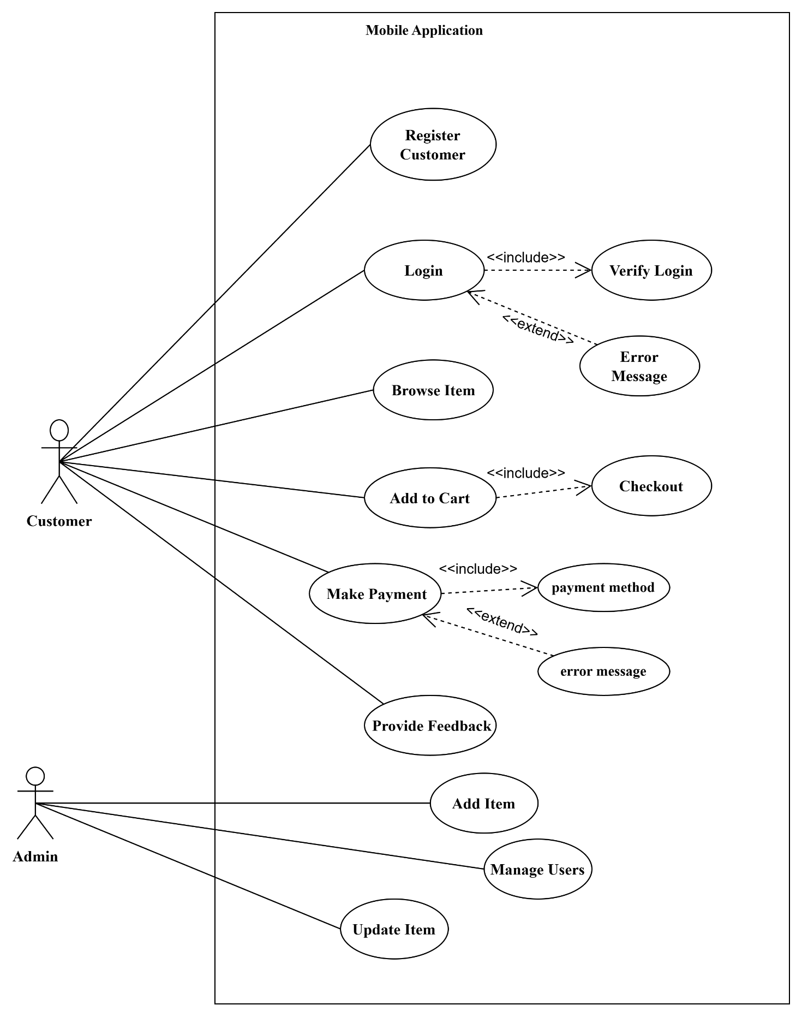

Figure 3.1 Use-Case Diagram for Quick-commerce website

Table 3.1 Use-Case Description for User Login
Usecase- Identifier | UC001 - Register New User and Login
Primary Actor | Customer (Buyer)
Secondary Actor | N/A
Description | The customer registers on the platform to create a new account and logs into the platform using their credentials.
Pre-condition | The customer must not have an existing account and must provide valid registration details.
Post-Condition | Customer is logged into the platform.
Failure Scenario | Registration fails if data is incomplete or already existsLogin and due to incorrect credentials.

Table 3.2 Use-Case Description for Browse Product
Usecase- Identifier | UC002 – Browse Product
Primary Actor | Customer (Buyer)
Secondary Actor | N/A
Description | The customer views available products and selects an item for purchase or further details.
Pre-condition | Customer must be logged in.
Post-Condition | List of products is displayed for browsing or purchase..
Failure Scenario | Products could not be retrieved due to database errors or network issues.

Table 3.3 Use-Case Description for Process Order
Usecase- Identifier | UC003 – Process Order
Primary Actor | Customer (Buyer)
Secondary Actor | Admin\Seller
Description | The customer places an order for a product, and the seller processes the order.
Pre-condition | The customer must have added items to the cart and be logged in.
Post-Condition | The order is processed and confirmed.
Failure Scenario | Order cannot be placed due to payment failure, insufficient stock, or technical errors..

3.1.3 Non-Functional Requirements
Non-functional requirements focus on how the system delivers its functionality. While they might appear secondary to functional requirements, they are crucial to ensuring a reliable and user-friendly system. These requirements influence system performance, usability, and overall experience.
- Speed: The system must handle transactions and load pages quickly, ensuring a smooth user experience.
- Security: Only registered users can log in, manage accounts, place orders, and make secure payments through the system.
- Availability: The platform should be accessible 24/7 to support online shopping without interruption.
- Ease of Use: Quick Commerce App(GroceryPlus) offers a simple, responsive, and intuitive interface for users.
- Usability: The system’s design and architecture ensure ease of use for customers, administrators, and sellers.

3.1.4 Feasibility Analysis
A feasibility study is a focused evaluation conducted early in the requirement engineering process. Its goal is to determine whether the system is practical to implement and worth developing. For Quick Commerce App, the feasibility study covers the following aspects:
- Technical Feasibility: Assessing whether the required technology stack (Java, XML, Android SDK, SQLite, FireBase) supports the project’s needs.
- Economic Feasibility: Evaluating the project’s cost-effectiveness for small and medium-sized businesses in Nepal.
- Operational Feasibility: Ensuring that users can easily adopt and benefit from the platform.
- Legal Feasibility: Confirming compliance with digital business regulations and payment gateway integration requirements.

3.1.5 Data Modeling
Data modeling involves creating detailed representations of the system’s data structures and relationships. This helps define the meaning and interactions of data elements. For Quick Commerce App, an ER Diagram (Entity-Relationship Diagram) will be used to illustrate entities such as users, products, orders, and payments, and their interrelations.

ER Diagram
ER diagram represents the real-world objects known as entities and their relationships with each other. The following is the ER diagram of Quick Commerce App.

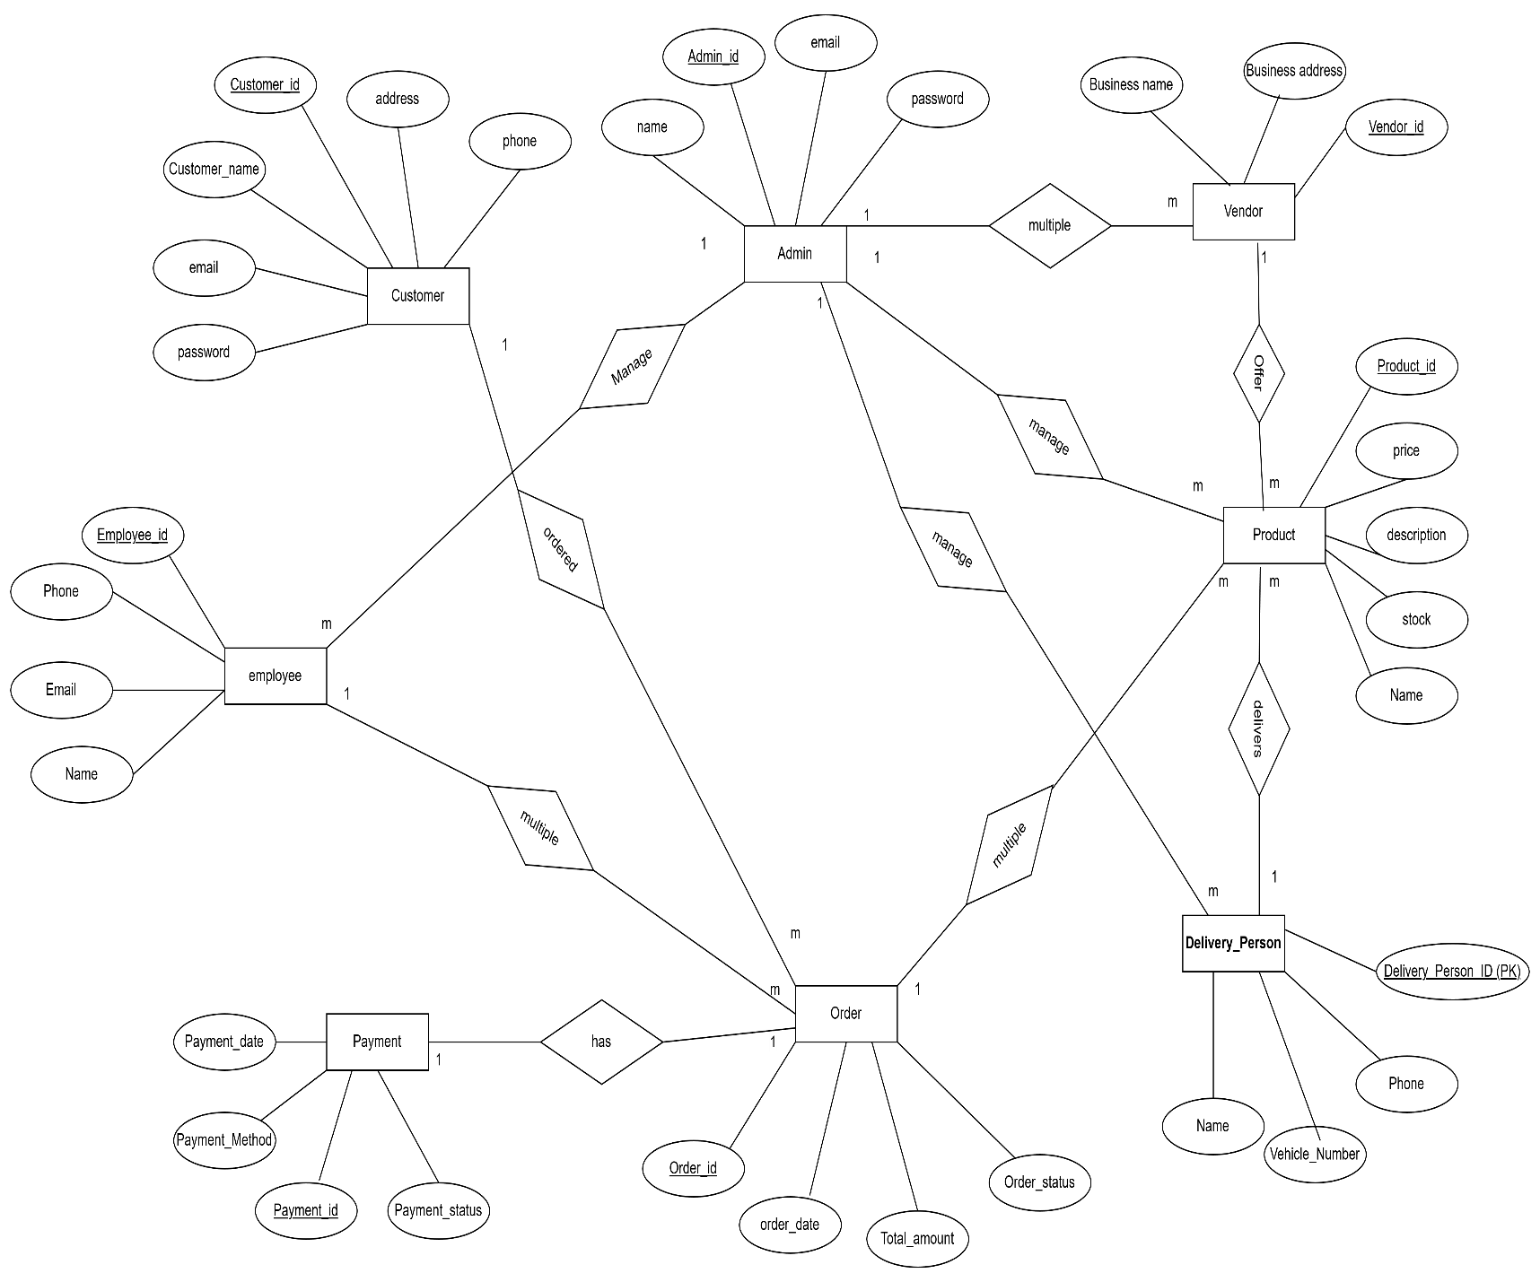

Figure 3.2 E-R Diagram of Quick Commerce App
This ER diagram represents the database structure for the Quick Commerce App(GroceryPlus) , capturing the relationships between various entities within the system.
Key entities include:
- Admin: Admins manage the system, including overseeing customer and product data, offering product categories, and managing orders and payments. Each admin has a unique ID, name, email, and phone details.
- Customer: Customers interact with the system by placing orders. They have unique IDs, names, emails, passwords, and shipping addresses. Orders are associated with a customer.
- Product: Products, managed by vendors, are categorized into different groups (Category). They include attributes such as name, price, description, and stock level.
- Category: Products belong to specific categories like electronics or clothing, each with a name.
- Order: When a customer places an order, it is recorded with details such as order ID, total amount, order date, and status. An order contains multiple products.
- Payment: Each order is linked to a payment record, containing details like payment status and amount paid.

3.1.6 Process Modeling
Process Modeling represents processes that capture, manipulate, store, and distribute data between a system and its environment and among the system components. Data Flow Diagram (DFD) is a formal way of representing of operation over the system.

Class Diagram
The Class diagram shows the static representation of the system. This extends on the Entity Relationship of a system and shows how the data tables are shown in the figure.
This diagram is without method:
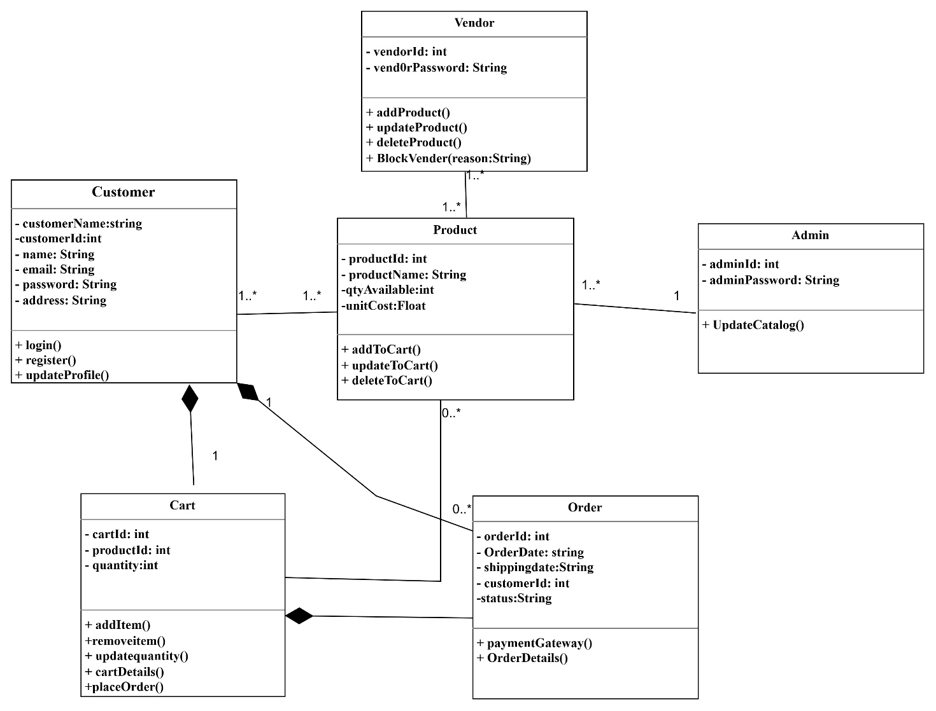

Figure 2.3 Class Diagram without method of Quick Commerce App

The diagram establishes essential relationships, where a customer can have multiple orders, a cart entry is associated with a single product, and orders are linked to specific customers. This structured approach provides a clear database model, ensuring efficient order processing, inventory control, and seamless user interactions within the Quick Commerce App(GroceryPlus) system.

CHAPTER 4: SYSTEM DESIGN

4.1 Design
System Design the process of defining the architecture, components, modules, interfaces, and data for a system to satisfy specified requirements. It follows requirement analysis and is a crucial phase in the software development lifecycle (SDLC). The goal of system design is to ensure that the system will meet both functional and non-functional requirements while being efficient, scalable, and maintainable.

4.1.1 Sequence Diagram
Sequence diagram is dynamic behavioral model which depicts the interaction among objects during a certain period of time. As the pattern of interactions varies from one use case to another, each sequence diagram shows only interactions for specific use case.
Following is the sequence diagram of Quick Commerce App is:

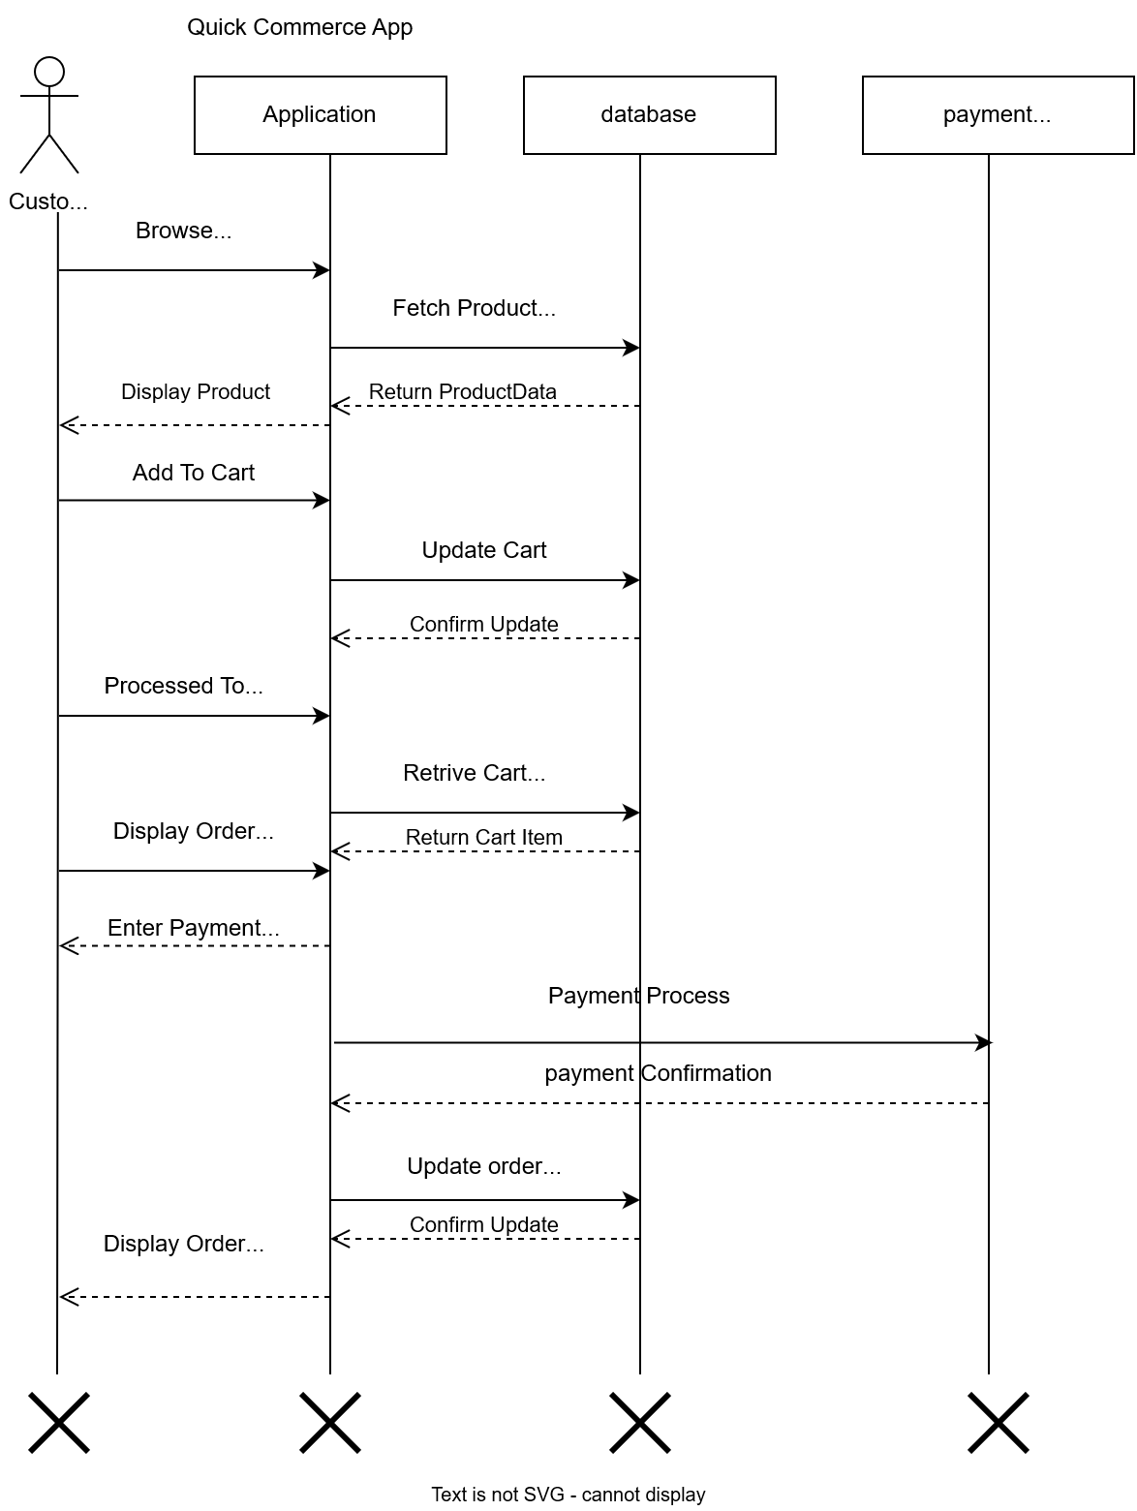
Figure 4.1 Sequence Diagram of Quick Commerce App (GroceryPlus)

4.1.2 Activity Diagram
Activity diagram is the behavioral model which provides dynamic aspects of the system’s process. Activity Diagram focuses on modeling procedural processing aspects of a system. It specifies the control flow and data flow between various actions required to implement an activity.
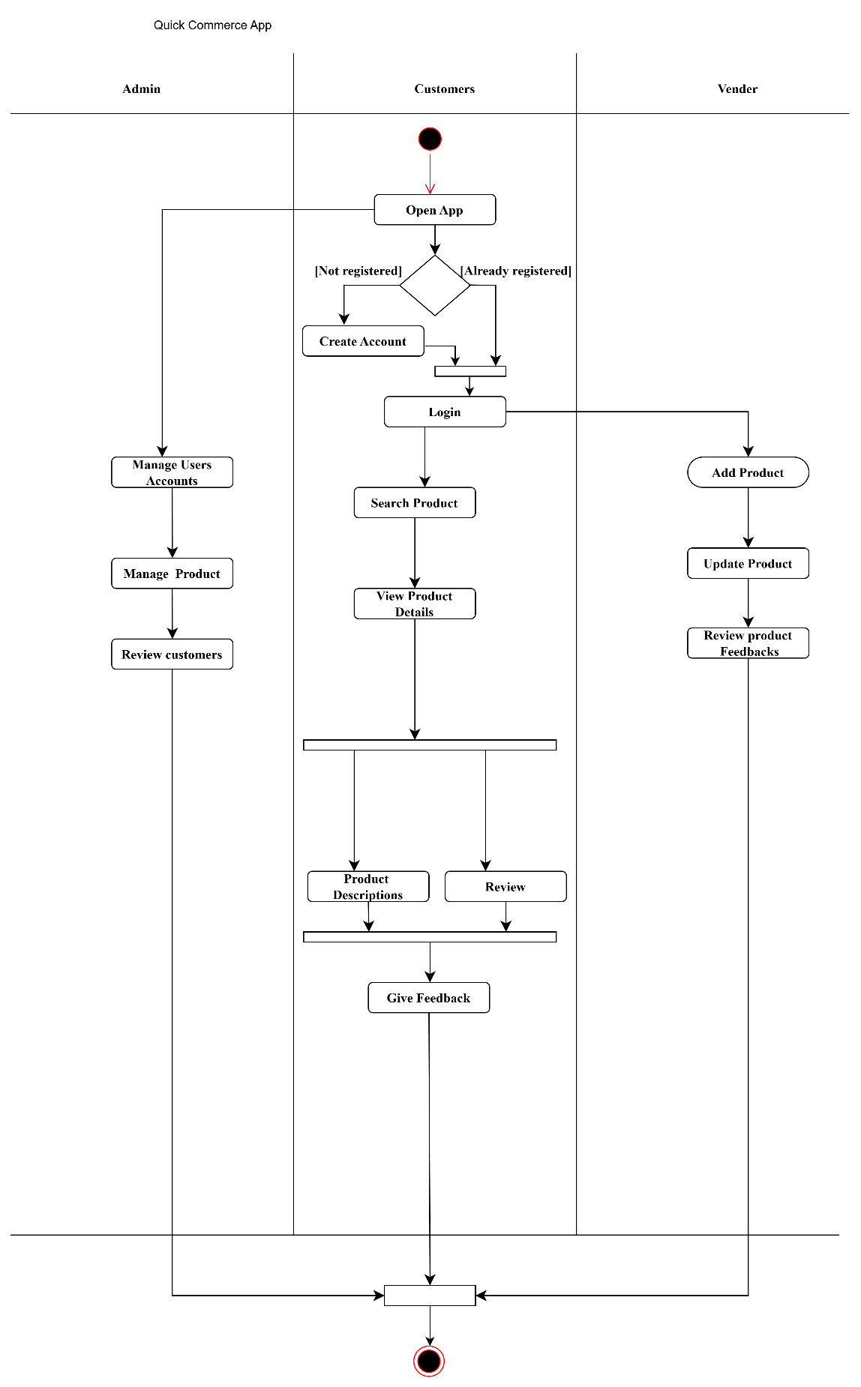
Figure 4.2 Activity Diagram for Quick Commerce App (GroceryPLus)

The activity diagram represents the flow of actions that occur during the process of a customer interacting with the FoodmanduOneMart quick-commerce App. It shows the steps a customer takes from browsing products to completing a purchase. The process begins with the customer logging into the system. Once logged in, they can browse through different products available for sale. After selecting a product, they add it to their shopping cart. The customer can continue shopping or proceed to checkout. During checkout, the customer reviews their cart, enters shipping details, and confirms the order.

4.1.3 Class Diagram
The Class diagram shows the static representation of the system. This extends on the Entity Relationship of a system and shows how the data tables are shown in the figure.

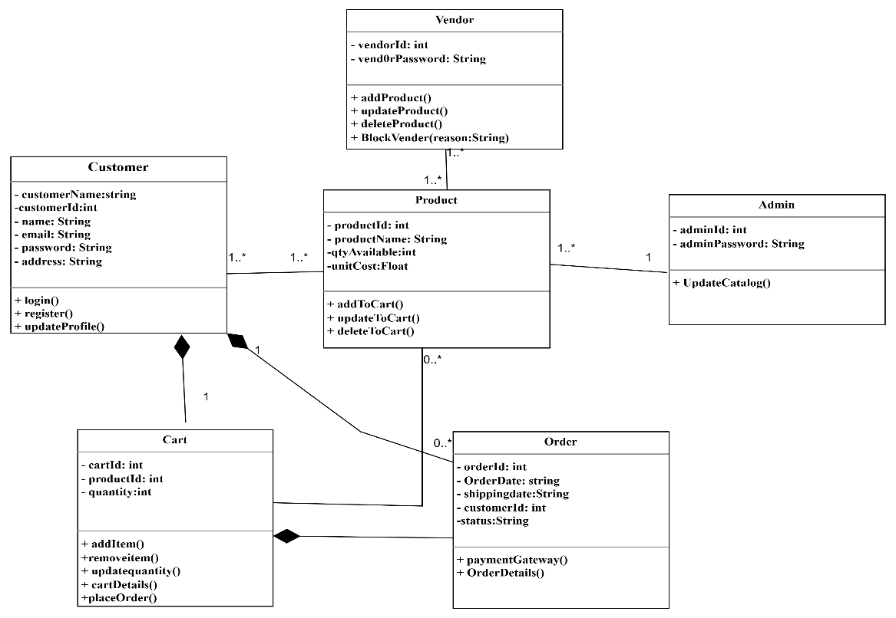
Figure 4.3 Class Diagram of Quick Commerce App (GroceryPLus)

The diagram establishes essential relationships, where a customer can have multiple orders, a cart entry is associated with a single product, and orders are linked to specific customers. This structured approach provides a clear database model, ensuring efficient order processing, inventory control, and seamless user interactions within the Quick Commerce App(GroceryPlus).

4.1.4 Component Diagram
A Component Diagram is a structural model that provides a high-level view of the system’s architecture. It focuses on modeling the static aspects of a system by representing its components, their relationships, and dependencies. It specifies the organization and interaction between various components required to implement the system.
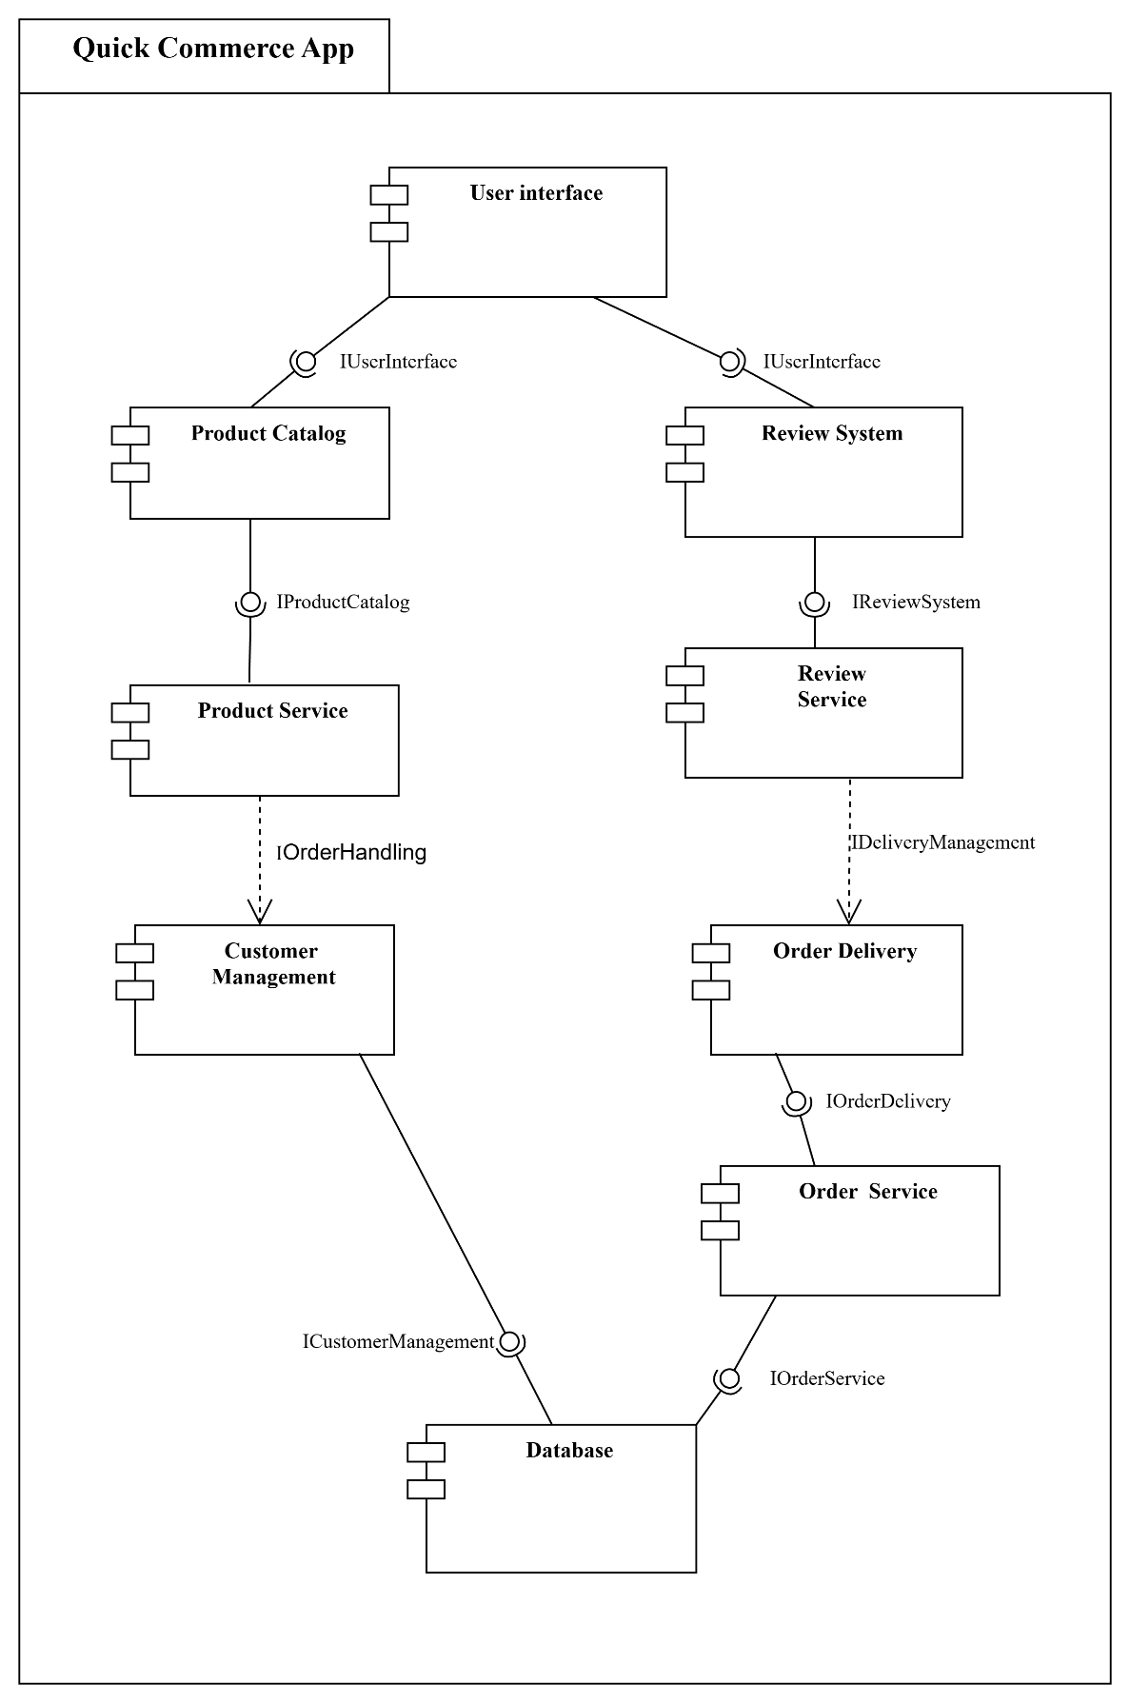
Figure 4.4 Component Diagram of Quick Commerce App
The User Interface (UI) is what the customer interacts with, allowing them to browse products, add items to the cart, and proceed with orders. The Authentication System handles user logins and registrations, ensuring that customers can securely access their accounts. The Product Management System manages the catalog of products available on the App, including adding new products and updating product details. The Order Management System handles the customer's orders, keeping track of order status and shipment details. The Payment Gateway processes payments when a customer completes a purchase, ensuring that the transaction is secure and successful. Finally, the Database stores all the data related to products, customers, orders, and payments.

4.1.5 Deployment Diagram
A Deployment Diagram is a structural model that represents the physical aspects of a system. It focuses on modeling the hardware components and their configuration, as well as the distribution of software components across these hardware nodes. It specifies how the system’s software and hardware interact, illustrating the physical deployment of artifacts and their relationships.
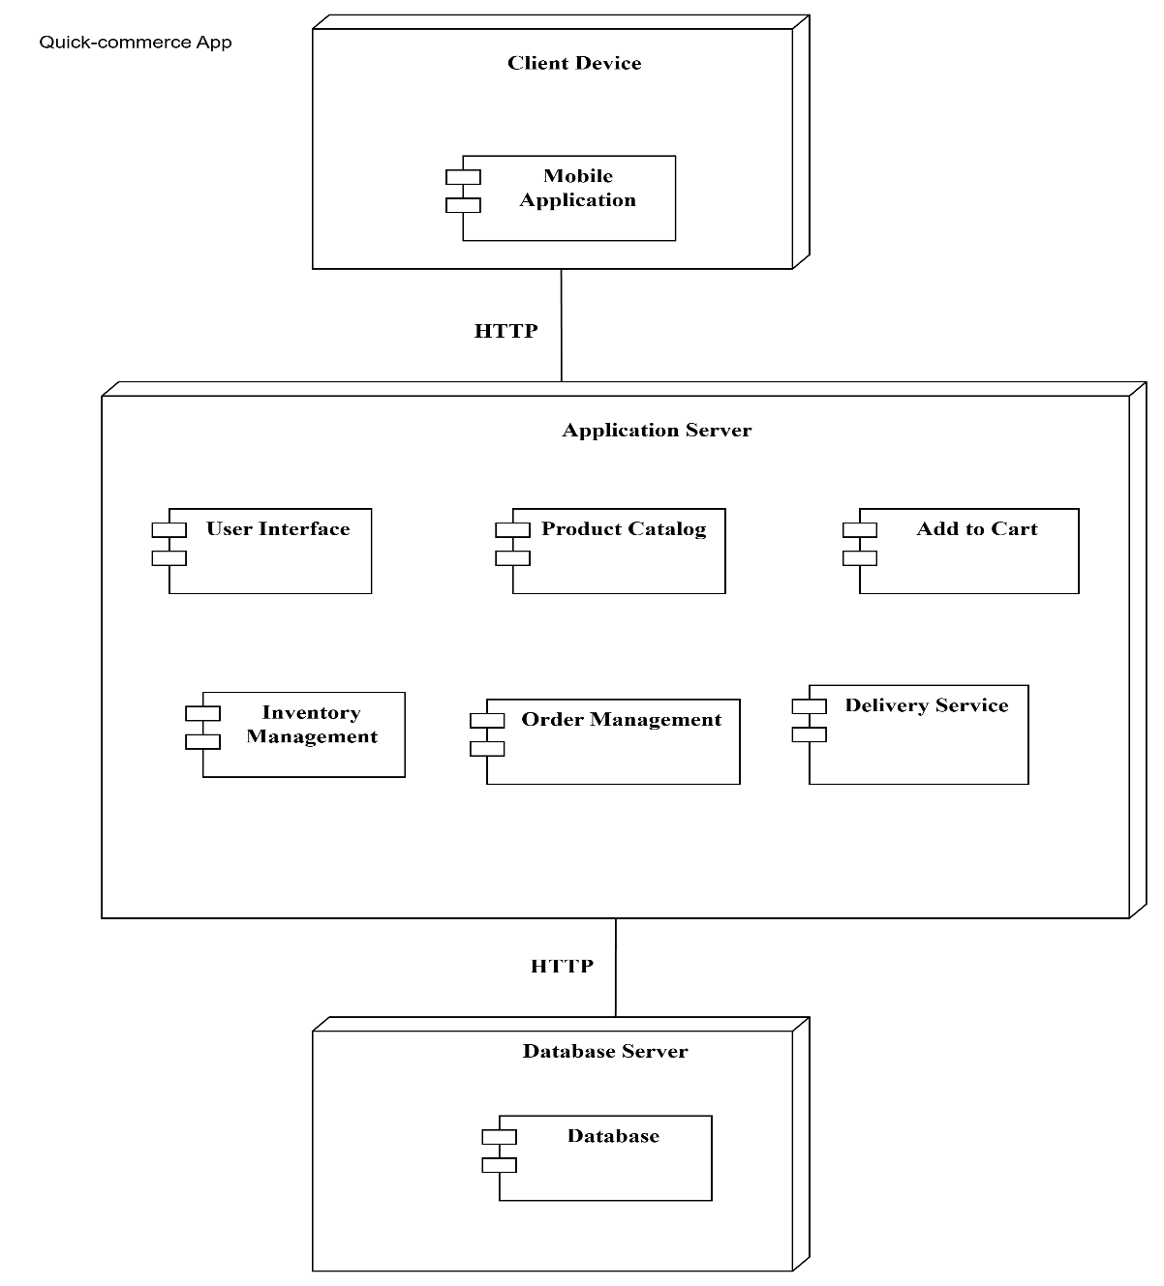
Figure 4.5 Deployment Diagram of Quick Commerce App

The diagram typically includes nodes like Mobile Client, Application Layer, and Local Database. The Mobile Client hosts the App and serves the user interface (UI) to customers when they access the app through their devices. It handles requests like browsing products, viewing the cart, and submitting orders. The Application Layer manages the business logic of the App. It processes customer requests, handles authentication, updates the order status, and manages interactions with the payment system.
The Local Database stores all the critical data for the App, including customer details, product information, orders, and payment records. It ensures that all this data is easily accessible and securely stored. Additionally, customers and admins interact with the system through their User Devices (such as Android smartphones or tablets), which communicate with the application layer locally on the device.
This deployment diagram shows how the system's components are distributed across different layers and how they work together to provide the functionality needed for a seamless mobile grocery shopping experience. It ensures the system is responsive, secure, and efficient by separating concerns into distinct, manageable layers.

CHAPTER 5: IMPLEMENTATION AND TESTING

5.1 Implementation

5.1.1 Tools Used
For the development of Quick-commerce App , we have used some specific front-end and back-end. Following are the tools used:
Front-end Tools
Following are the tools used in developing our system:
- XML

Back-end Tools
Following are the back-end tools used in developing our system:
- PHP
- JAVA

5.1.2 Implementation Details of Module
A module is a collection of source files and configurations designed to address a specific functionality of the system. Each module in Quick Commerce App(GroceryPlus) has a single, well-defined purpose and is built using the MVC architecture. Below are the modules implemented:
- Login Module: Handles user authentication for registered admins, sellers, and customers.
- Register Module: Allows new users to create accounts in the system.
- Product Module: Manages product listings, including adding, updating, and deleting items.
- Order Module: Facilitates order creation, tracking, and history for users.
- Cart Module: Allows users to manage their shopping carts, including adding and removing items.
- Payment Module: Integrates with the Stripe payment gateway to process transactions securely and store payment details.

5.2 Testing
Testing is a critical phase in the development process to ensure the functionality and reliability of the application. The primary objective of the testing process is to identify and rectify defects.
Quick Commerce App(GroceryPlus) was tested using multiple testing techniques to ensure its functionality, usability, and security. The following testing methods were used:
- Unit Testing – Testing individual modules such as product listing, cart management, and checkout.
- Integration Testing – Checking interactions between different modules (e.g., user authentication and order processing).
- System Testing – Ensuring that the system meets functional and nonfunctional requirements.
- User Acceptance Testing (UAT) – Testing with real users to verify usability and performance.

5.2.1 Unit Testing
Unit testing is the process of testing the smallest part of your code, like individual functions or methods, to make sure they work correctly.
The purpose of unit testing is to test the correctness of isolated code. A unit is component is an individual function or code of the application. White box testing approach used for unit testing and usually done by developer.
The login module was tested using following scenarios:
Table 5.1 Unit Testing for Login menu
S.N. | Test Scenario | Actions | Input Data | Expected Outcome | Observed Outcome | Result
1. | User Login with valid credentials | Open Login page and enter valid data | Username: lili@gmail.com  Password: 123456 | Redirect to the dashboard | As expected | Pass
2. | User Login with invalid data | Open login page and enter invalid details | Username: lili@gmail.com  Password: 1234 | Login failed error | As expected | Pass

5.2.2 Integration Testing
Integration testing ensures that two or more individual modules, previously tested in isolation, work together seamlessly. This testing focuses on verifying the interfaces and data flow between interconnected components.
In Quick Commerce App, various modules have been integrated, including the login, product, cart, order, and payment modules. The system is also integrated with the external payment gateway (Stripe) for payment operations, eliminating the need for an in-house payment processing system. For instance, the order module relies on the login module to function properly.
All integrated modules have undergone thorough testing to ensure smooth operation and compatibility, maximizing the system's performance and reliability.

5.2.3 System Testing
System testing involves assembling all components of the platform into a complete system and testing it as a whole. This process verifies the compatibility of components, the accuracy of data transfer across interfaces, and the overall behavior of the integrated system.
For Quick Commerce App, system testing was conducted to ensure that all modules—such as product management, user authentication, cart, order processing, and payment—integrate and function correctly. This phase confirmed the system's readiness for deployment and its ability to handle real-world scenarios effectively.

CHAPTER 6: CONCLUSION

6.1Conclusion
Through the development of Quick Commerce App (GroceryPLus), I gained valuable insights into implementing an quick-commerce platform in a real-world context. The system was successfully implemented as a android application, leveraging internet-based technologies to meet user requirements.
During this process, I explored various aspects of system design, development, and testing. Specifically, I conducted unit testing and integration testing, which provided a deeper understanding of system reliability and performance. This project has been a significant learning experience, highlighting best practices and methodologies for building robust, scalable applications.

6.2Future Recommendations:
To further enhance the functionality and usability of Quick Commerce App, the following features could be implemented in the future:
- Nearby Store Detection: Recommend nearby grocery stores based on user's GPS location.
- Delivery Hub Optimization: Suggest nearest delivery centers for faster service efficiency.
- iOS & Web App Development: Expanding the system’s reach by developing a dedicated application for Web and iOS platforms.
- Route Planning: Optimize delivery routes based on real-time traffic.

References

[1] | Milon Bhattacharya, “A Mathematical Model for Pricing Perishable Goods for Quick-Commerce Applications” (arXiv preprint, 2025).
[2] | Yajing Chen et al., “An Integer Programming Approach for Quick-Commerce Assortment Planning” (arXiv preprint, 2024)..
[3] | . Prithvi Kewalramani & Harshad Khadilkar, “Heuristic for Optimization of Dark Store Facility Locations for Quick Commerce Businesses” (arXiv preprint, 2023)

APPENDICES

Register:
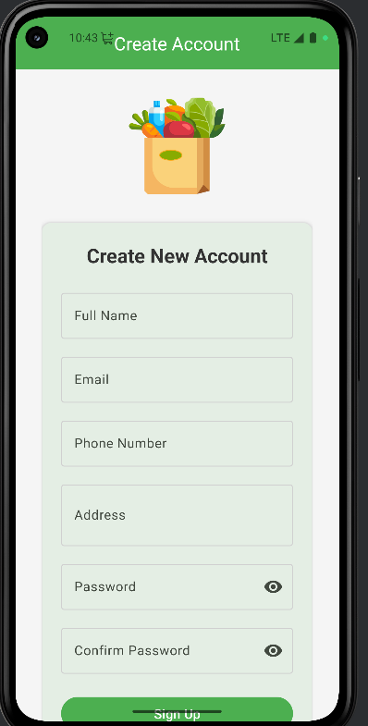

Login:
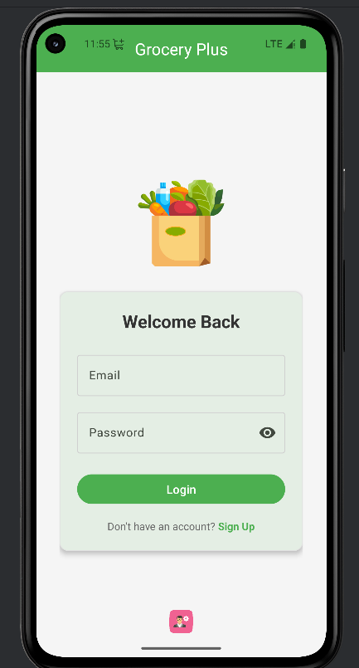

Admin Area:
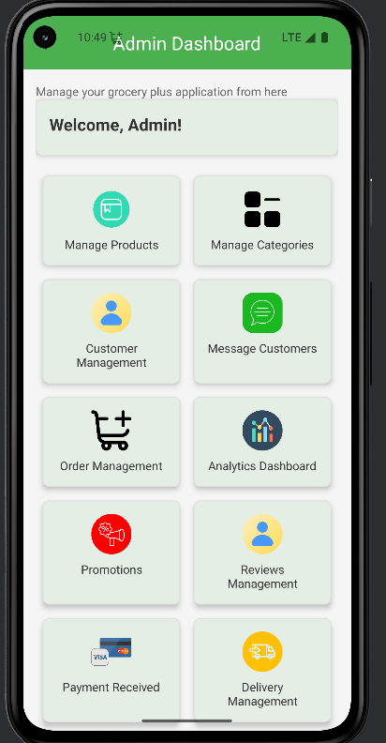

Order History:
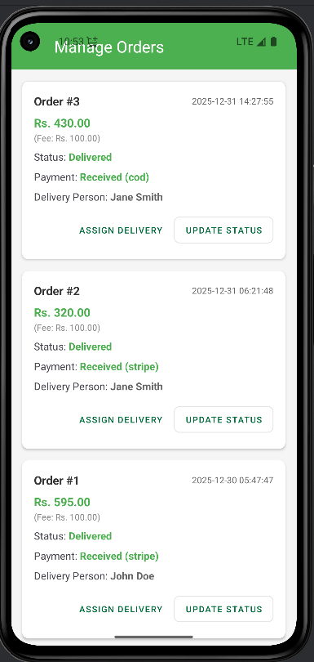

Checkout :
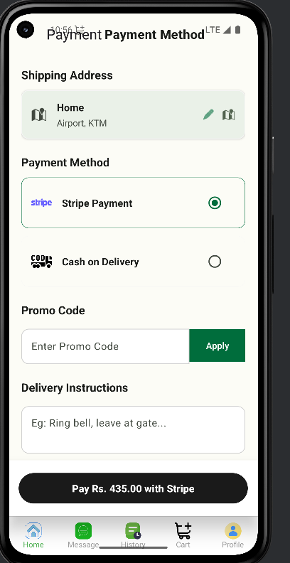

Home Interface

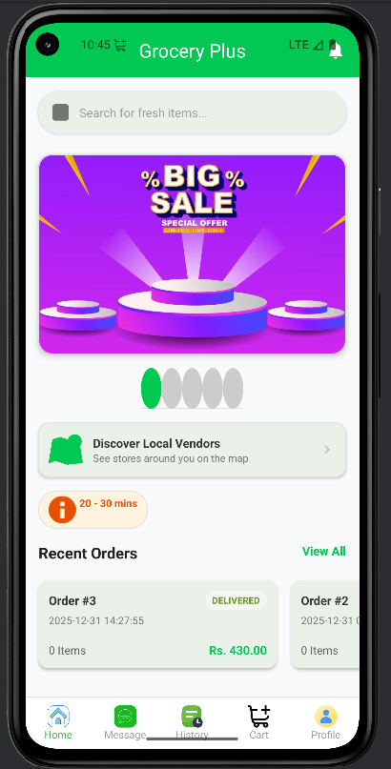

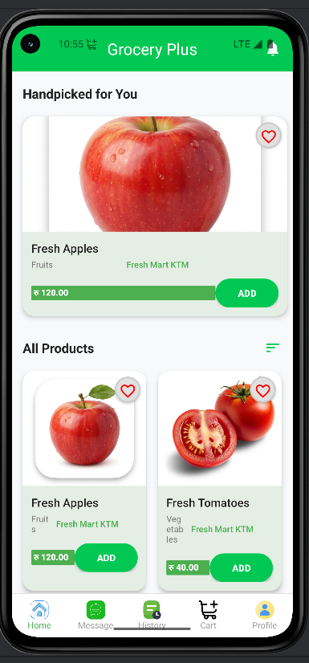

Cart :
